Unit Title: Creation is Calling
Integrating Catholic Social Teaching Across the Curriculum
Year: 3 Term: 4 Classes: 3N Teacher: Leann Bridge
School: St Anthony’s Catholic Primary School Alexandra Hills

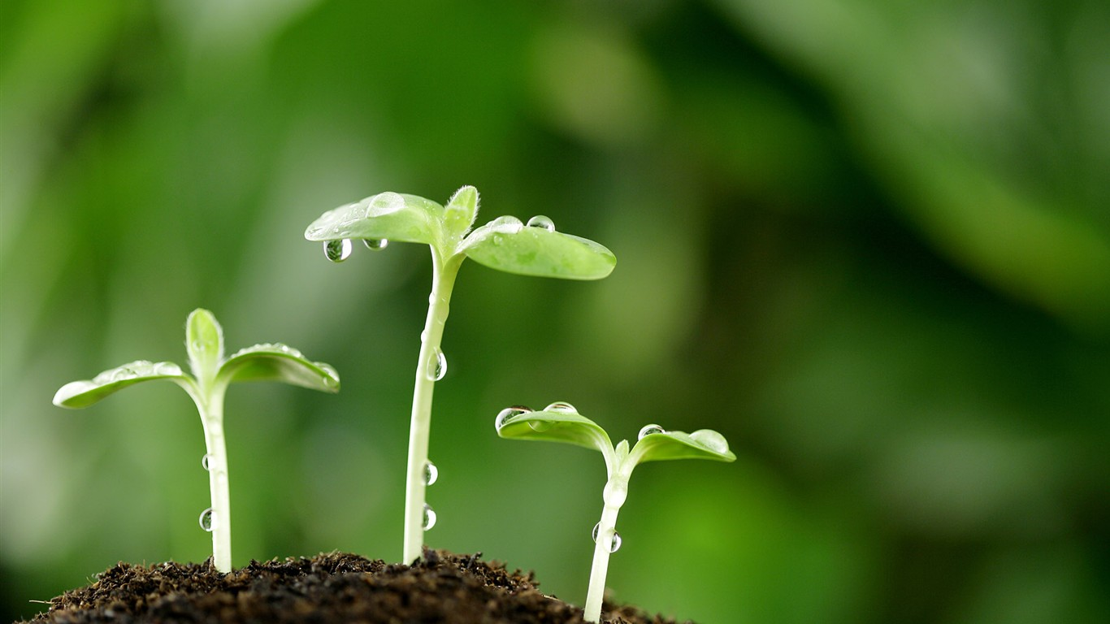
“ …how inseparable is the bond between concern for nature, justice for the poor, commitment to society, and interior peace.”
Pope Francis – Laudato Si’
Aboriginal and Torres Strait Islander Histories and Cultures
- Dreaming stories

Digital Technologies
- Follow up activity – “Grandpa’s prayers for the Earth”
by Douglas Wood
English
- “The Lorax”
Comparing movie and book
- “My Two Blankets” refugees
- “Christmas Mother”
St Vinnie’s Appeal

Religion: Creation is Calling
- Order and harmony
- human rights
- Lauato Si – Pope Message
- prayers of praise
- meditative prayer

Maths
- Interpret and compare data displays
- turtles and koalas decline in Redlands
Humanities and Social Sciences
- examine climate and the types of settlements in …, and Australia's neighbouring countries
- Kirabiti and other islands

Visual Arts
- Reverse Garbage Workshop
- Create Class Book – Our Beautiful Bay

1
Clean Water
- Nothing lives without water
- Dirty water carries germs that make us sick
- Water is good to do sport
- Don’t tip dirty water into clean water
Cooper, Gracy, Bianca, Rayne
Each Other
- We respect each other because without each other we won’t have the power of friendship and love. We always need each other to help us.
Kyle, Bentley, Poppy
Land
- No land – we drown
- The earth is our home
- Shelter
- Stable ground
- Without it the earth would have no trees
Pez, Grace, Zeke, Joselito

Why should we value …….?
God – he is the creator of all things
All Plants
- We should take care of plants because they give us oxygen and they give us food and shade and they also give us animal homes

Mikhail, Jemar
Montana
Fresh Air
- We breathe air
- Animals breathe air
- Dirty air makes us sick
- Plants breathe air
- Used as medicine
- If we don’t have air we die

Emma, Jas, Liam
All Creatures
- We should value all creatures because they provide us with food, with nutrients, to live.
- They also comfort us. They also keep us warm.
Joseph, Veronica, Vejay and Dante
Ten Principles of Catholic Social Justice Teaching

1. Everyone and is created in the image of God and should be treated with respect.
2. Everyone has the right to a happy, healthy, safe life.
3. Everyone is different and we should accept each other’s differences.
4. Everyone has a responsibility towards shaping a fair and just world.
5. Everyone should put the needs of the poor and vulnerable first.
6. Everyone should care for our neighbours both near and far around the world.
7. Everyone has a responsibility to care for all of God’s creation.
8. Everyone’s role is to help others to help themselves.
9. Everyone is created equal in the eyes of God and deserves a fair go.
10. Everyone has a responsibility towards making it a better world for everyone and everything.

- Principles chosen by students as being related to Creation Story at beginning of unit.
3

Student Reflections on Laudato Si
Emma:
- Look after the creation. Don’t destroy it. If we destroy it everything will be gone.
Cooper:
- We should look after all nature because we are all one family and we all should treat each other like neighbours.
Joseph B:
- We need to stop climate change because we are losing lots of little islands which are homes to lots of people but we can help by changing little things like using bikes instead of cars.
Pez:
- God created everything in his image and he wants us to treat it fairly and equally.
Leilah:
- We need to look after our world and clean up after ourselves because if we leave rubbish everywhere the animals and people will get sick.
Vironica:
- We should value our homeland because if we keep on being greedy there won’t be any nature and we won’t be able grow any food and there won’t be any people living in our homeland
4
Jas:
- We need to value our clean water. If we keep littering, it will go into our creeks which lead into our oceans.
Kyle:
- We should take care of the animals so they don’t become extinct because they were created in God’s image too.
Grace:
- God gave us a beautiful world, however due to people leaving rubbish everywhere and polluting the air, people are destroying it. We should enjoy not destroy. We should treat it with respect.
Bentley:
- It is the poor people who are being affected the most.
Zeke:
- We should listen to the indigenous peoples because they are the ones looking after the trees and the earth. They only take what they need.
Bianca:
- We should look after the earth because the earth provides us with everything we need to survive.
Liam:
- If we look after the earth it will look after us. 5
Kiribati – A Call to the World student responses
- Waters are rising around the island
- Storms and high tides are becoming more frequent
- Gardens are being destroyed by the salt water coming up through the ground
- Salt water is getting into the freshwater lagoons
- Crops and fruit trees are being battered by storms
- Water is surrounding their villages and covering their roads making it hard to move around
- Some houses have already been abandoned
- A lot of droughts are causing their crops to dry out
- Harder to grow food for themselves
- Stronger winds batter the islands
- The walls they have built are being destroyed because the sea is stronger
- Planted the mangroves to try and keep the water out
- Called out to the world to decrease greenhouse gases by 80% but the
- world only agreed to 8%
- At a loss as to what else to do
- Calling to the world for help because it’s everybody’s problem 6
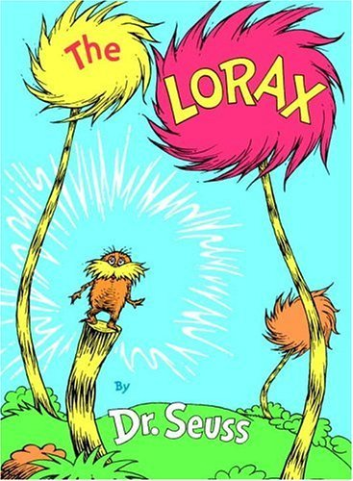
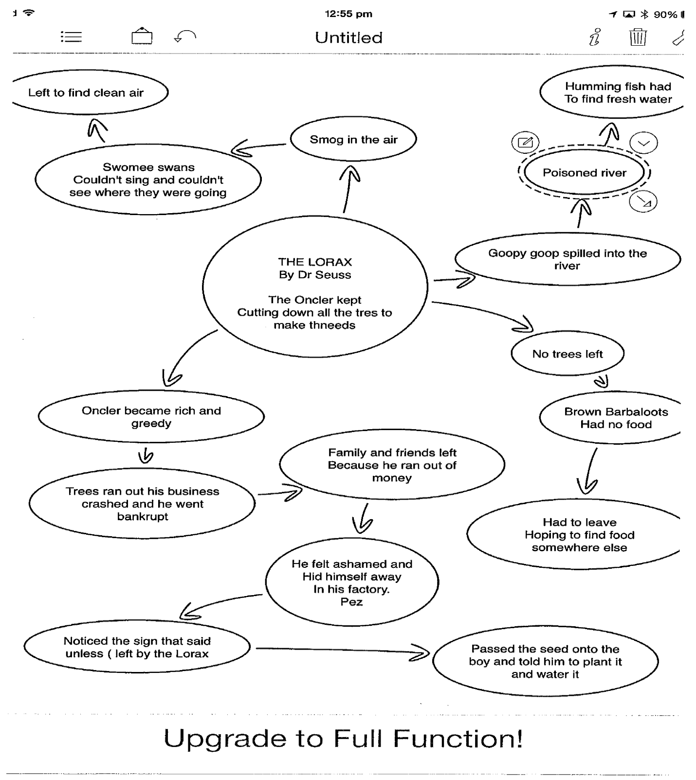
7
The Lorax by Dr Seuss
- Consequences Web
Maths – Statistics - Interpret and compare data displays (ACMSP070)

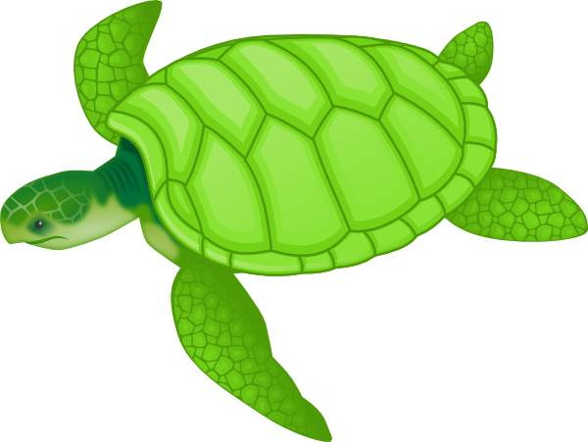
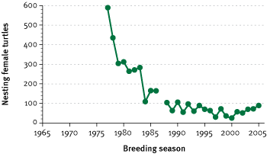

Figure 7.8 Number of nesting females tagged during the two-week annual mid-season tagging census at Wreck Island
Source: Limpus and Limpus 2003, and QPWS Marine Turtle database

www.ehp.qld.gov.au/state-of-the-environment/report-2007/biodiveristy_species_protection.html

8
3M’s Reflections on the Creek

I saw a very small cacoon on a very thin branch with very few leaves on it.
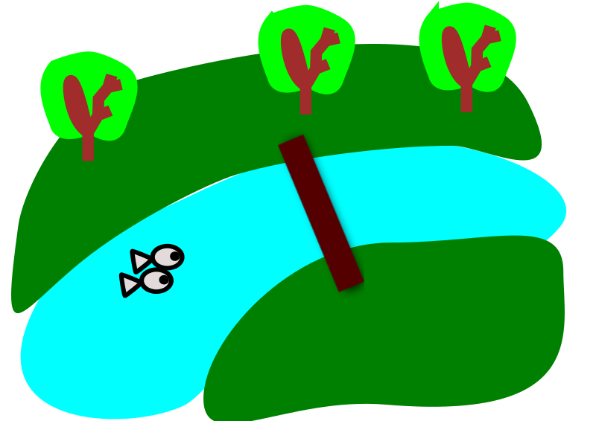
It was swaying in the breeze.
Baby caterpillar eggs on some leaves.
Two small butterflies fluttering around from tree to tree.
Three big ants standing as still as statues.
Little ants scurrying around on the bark of a tree.
A tiny little insect lying as still as a log on a piece of bark.
Seven baby grass hoppers standing still.
Yellow and pink eggs stuck on a leaf.
A whole lot of large ants scurrying around.
Two birds dancing, flapping their wings and moving from branch to branch.
A spider climbing up the tree.
A purple leaf blowing in the wind.
Some bumpy little green things on a little branch. I wonder what they are?
I hear heard the trees waving their branches in the wind.
Two dogs barking on the other side of the creek.
Crickets chirping. Dadirri – inner Deep Listening and Quiet Still Reflection
9
Creation is Calling – overall Unit Reflections
Name, class, school: Leann Bridge 3N St Anthony’s Catholic Primary School

Action Research Problem: How to integrate Catholic Social Teaching (CST) in a planned way
Student outcomes – knowledge, understanding, attitudes, behaviour | Observed outcomes with respect to knowledge and understanding of CST  The CST Principles addressed in the Creation Calls Unit as seen by the students.  - Whereas the student had previously only highlighted Principles 7 and 10, they identified all the principals as relating to environmental issues and were able to give example for each.  Observed outcomes with respect to related attitudes and behaviour…. (in case of behavior, intentions to change behavior might be noted)  - At the beginning of Year Three the students are very self-orientated.  - Throughout the unit the students have become globally aware students who have taken ownership of the small actions that they can take to bring about a more fair and just world for all of creation.  - They have pulled together as a class, showing a great deal more respect for each other’s differences.  - They have enjoyed being positive leaders for the rest of the school.  - Less reliant on extrinsic rewards as motivation.  - Proud of their achievements.  NOTE: reasons for observed outcomes are important i.e. increased understanding, increased appreciation of CST, combination of both….
Teacher outcomes – knowledge, understanding etc. | Any impact on your own knowledge, understanding, attitudes, behavior, teaching??  e.g. your attitudes towards planned integration of a Catholic perspective; your awareness of Catholic Social Teaching…  10  - Don’t underestimate the younger students’ ability to understand and act on global environmental and social justice issues.
Teacher reflections e.g. changes for future/lessons learned from action research. | What were the successes? Why?  - The students deepened understanding of Laudato Si and their role in the ongoing creation story.  - The students level ownership of their leadership projects – Advent Prayer Parade based on Laudato Si, promotion of St Vincent de Paul Christmas Hamper Appeal, Koala Conservation Agreement Program and the Adopt-a-Creek Project.  - Their level of commitment to the prayer activities.  What areas might be improved? Why?  - Continue to find resources suitable for youngers students  - Instead of a general report card from God – Use the report card to reflect how the School is doing with respect to caring for creation or an individual report card.  The key action research question: If I was to attempt integration of CST again with this or another Unit what would I do differently? Why?  - Conducting the rubbish audit with the students and have them make suggestions as to how we can show leadership in this area e.g. NUDE FOOD DAY  - Creating a class consequences web about climate change  - I would make use of Children’s books like  My Two Blankets  By Irena Kobald, Freya Blackwood (Illustrator)  to help the students how we can make refugees feel welcome in our community.
Conclusion, other comments | What is/is not feasible with respect to integration of CST in a planned way?  - It is imperative that we integrate the CST Principals across the subject areas. Not only does it help connect the subjects, it is of real relevance to the students as it enables them to take positive action for a better future for themselves, each other and the earth.  - Catholic Social Justice teaching needs to permeate everything we do with our students if they are to be actively involved in bringing about a more fair and just world for all of creation.
11

